The Jane Schieber Laskowski
Kickstart Scholarship
of The Erie Community Foundation

APPLICATION DEADLINE – April 15

The Erie Community Foundation is pleased to accept applications for the Jane Schieber Laskowski Kickstart Scholarship.

The purpose of this scholarship is to assist one student attending any qualified two-year program based in Erie County, while maintaining part-time employment. Candidate must maintain 6 credit hours minimum, per session/semester and a “C” average in every class. Preference will be given to candidates who are 21 or older.

Applications must include the following:

1. A completed application form
2. An official academic transcript of applicant’s most recent grades (if already in enrolled in program)
3. One letter of recommendation
4. 350-500 word essay demonstrating qualification/need of scholarship
5. Completed Financial Information form

Name Birth Date

Home address

City State ____________ Zip _ U. S. Citizen Yes No

Home Phone _____________________________ E-Mail

High School Attended Year Graduated

Trade/Vocation or College/University in which you are currently enrolled

Field of Study Projected graduation date

Place of Employment Hours worked per week

Financial Information

Estimated College/Vocational Expenses:

Tuition $

Room/Board $

Other $

Total $

Existing Sources of Funds available for College/Vocational:

Family $
Personal $ (savings, earnings, etc.)

Scholarships/grants $
Loans $

Total $

This application should be submitted to the Erie Community Foundation no later than April 15th.

Signature Date

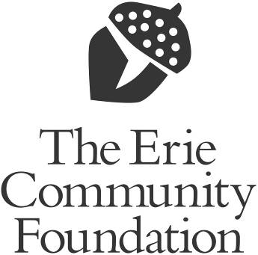

459 West 6th Street
Erie, PA 16507

Helping today…Shaping tomorrow

