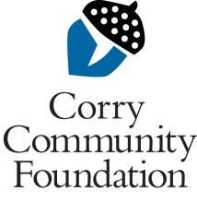

Larry Amy

Engineering

Scholarship

APPLICATION DEADLINE – April 15, 2016

The Corry Community Foundation is pleased to accept applications for the Larry Amy Scholarship.

The purpose of this scholarship is to assist graduates of Corry Area High School who have achieved sophomore or junior level status and are majoring in an Engineering program with preference given to someone enrolled in a Civil Engineering program.

Applications must include the following information:

1. A completed Application Form including financial information

2. A letter of introduction describing your engineering interests and professional goals.

3. An official Academic Transcript including most recent grades.

4. Confidential letters of reference from at least two professors in the applicant’s degree program.

Completed applications should be postmarked by April 15th and submitted to:

Joe Amy
143 Raymond Ave.
Corry, Pa. 16407

Application
Larry Amy Scholarship

Name Birth Date

College address College Phone

City State ____________ Zip ___

Home address
City State__________ Zip U. S. Citizen Yes No

Home Phone _____________________________ E-Mail

College Name Engineering Field of Study

2016/2017 status: Sophomore Junior

Projected Graduation Date

A. List community service

B. List extra-curricular activities

Application
Larry Amy Scholarship

C. List honors and awards

D. List work experience

E. List the names of others in your household who are also attending advanced schooling:

______

Application
Larry Amy Scholarship

FINANCIAL INFORMATION
(all information will be kept confidential)

Estimated Annual College Expenses: (2016-2017)

Tuition $

Room/Board $

Books $

Other $_________________

Total $_________________

Existing Sources of Funds:

Family $

Personal $ (savings, earnings, etc.)

Scholarships/grants $

Loans $

Total $

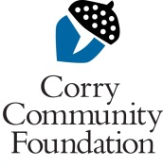
Signature Date

